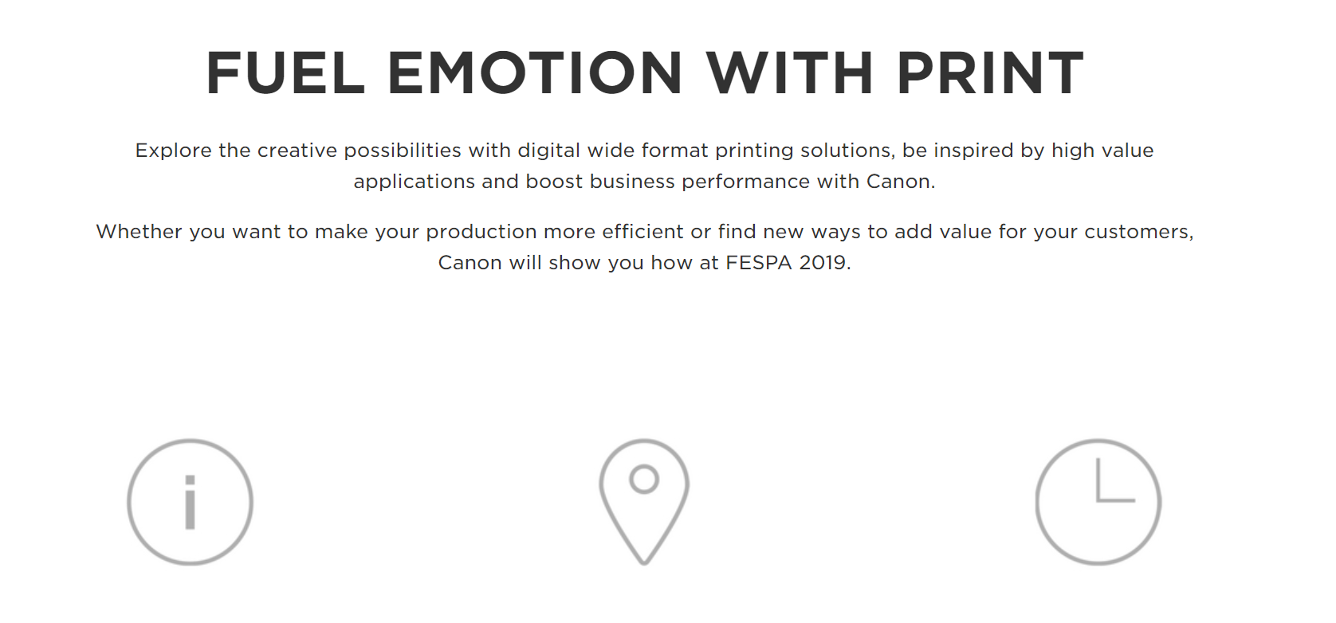
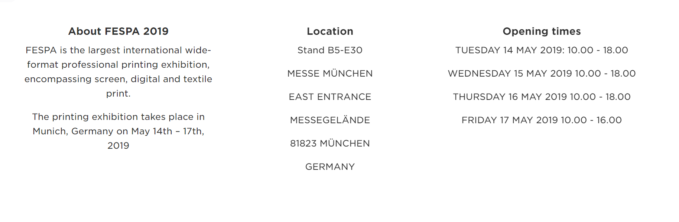
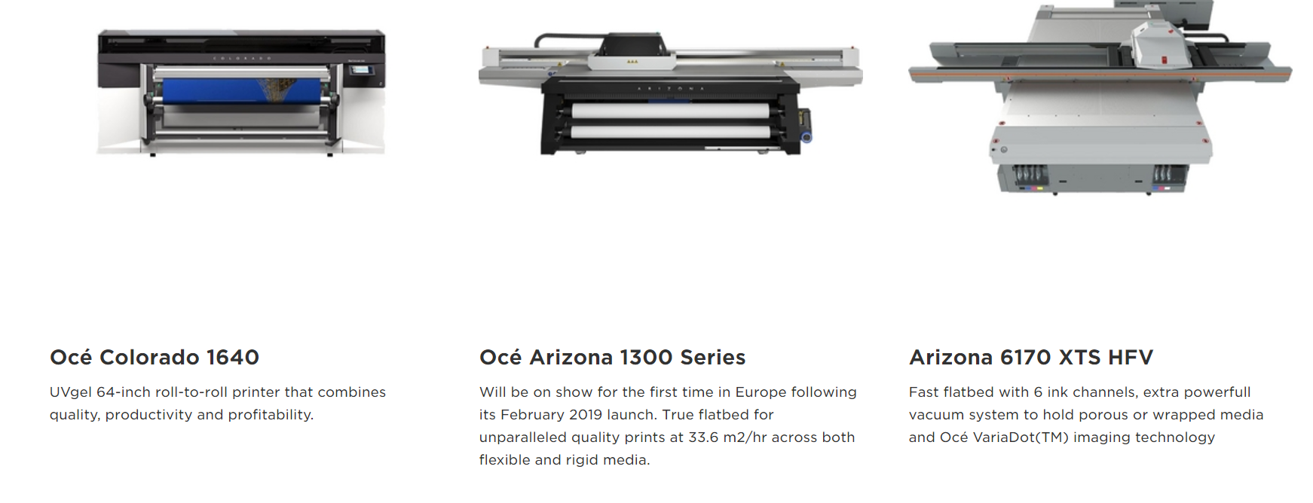
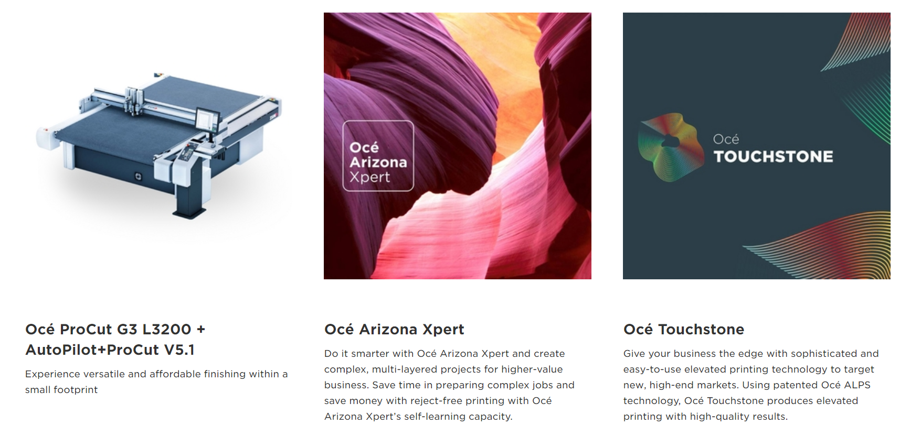

Join Canon at FESPA 2019
14 - 17 May 2019 in Munich Messe
Stand B5-E30
REGISTER FOR FESPA 2019

FUEL EMOTION WITH PRINT
Explore the creative possibilities with digital wide format printing solutions, be inspired by high value applications and boost business performance with Canon.
Whether you want to make your production more efficient or find new ways to add value for your customers, Canon will show you how at FESPA 2019.

About FESPA 2019
FESPA is the largest international wide-format professional printing exhibition, encompassing screen, digital and textile print.
The printing exhibition takes place in Munich, Germany on May 14th – 17th, 2019

Location
Stand B5-E30
MESSE MÜNCHEN
EAST ENTRANCE
MESSEGELÄNDE
81823 MÜNCHEN
GERMANY

Opening times
TUESDAY 14 MAY 2019: 10.00 - 18.00
WEDNESDAY 15 MAY 2019 10.00 - 18.00
THURSDAY 16 MAY 2019 10.00 - 18.00
FRIDAY 17 MAY 2019 10.00 - 16.00
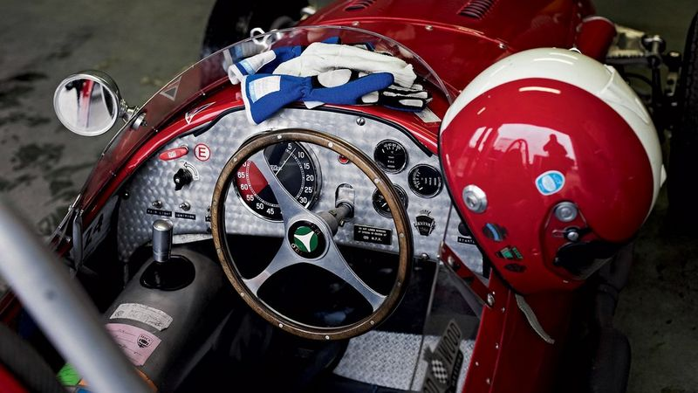

FUEL NEW OPPORTUNITIES
Canon will showcase a range of wide format applications to illustrate the emotional power of print and how it can be used to create an inspiring, unique & unexpected experience for consumers from home to street to store. You will discover a promotional campaign for ‘Speed’ - a story of emotional print. It started with a photobook of lifestyle images captured by Horst A. Friedrichs, followed by a myriad of promotional and merchandising print applications demonstrating the power, unique application opportunities and quality of digital print. We also supported Horst with out-of-home advertising, point-of-sale materials and an unique and haptic invitation for the book launch.
Watch Video

FUEL BUSINESS GROWTH
Be inspired by our innovative technology solutions and learn how the ground-breaking Océ Colorado with Canon UVgel technology and latest developments in the Océ Arizona Series are driving growth and creating fresh opportunities for a lot of current and new customers.

Products and technologies on show
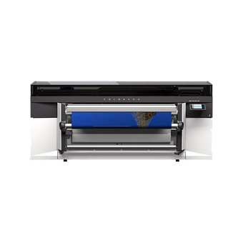

Océ Colorado 1640
UVgel 64-inch roll-to-roll printer that combines quality, productivity and profitability.
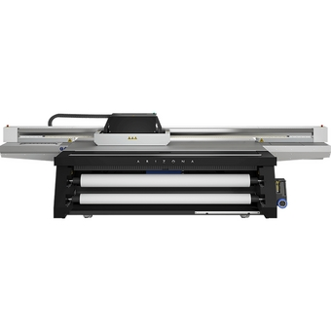

Océ Arizona 1300 Series
Will be on show for the first time in Europe following its February 2019 launch. True flatbed for unparalleled quality prints at 33.6 m2/hr across both flexible and rigid media.
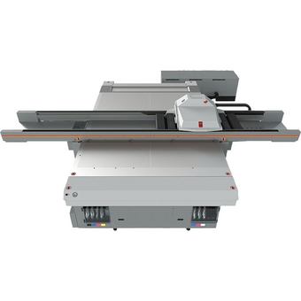

Arizona 6170 XTS HFV
Fast flatbed with 6 ink channels, extra powerfull vacuum system to hold porous or wrapped media and Océ VariaDot(TM) imaging technology
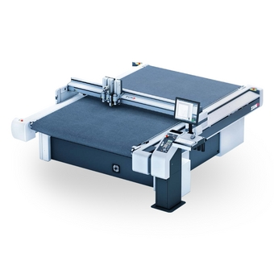

Océ ProCut G3 L3200 + AutoPilot+ProCut V5.1
Experience versatile and affordable finishing within a small footprint

Océ Arizona Xpert
Do it smarter with Océ Arizona Xpert and create complex, multi-layered projects for higher-value business. Save time in preparing complex jobs and save money with reject-free printing with Océ Arizona Xpert’s self-learning capacity.

Océ Touchstone
Give your business the edge with sophisticated and easy-to-use elevated printing technology to target new, high-end markets. Using patented Océ ALPS technology, Océ Touchstone produces elevated printing with high-quality results.
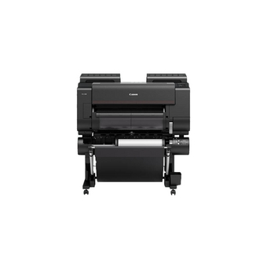

Canon imagePROGRAF PRO-2000
The ultimate large format printer for photographic and fine art printing - with unparalleled 24-inch production output and reliability.

Register for FESPA 2019
If you'd like to visit Canon at FESPA 2019 please use the link below to register. (no code required)
REGISTER FOR FESPA 2019

